Assignment 7

Major MQTT Client Libraries Across Different Programming Languages
MQTT client libraries help applications communicate with MQTT brokers using the MQTT publish/subscribe protocol. Different programming languages provide specialized libraries optimized for IoT and embedded systems.

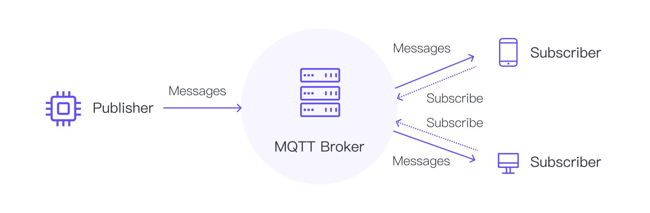
Common MQTT Client Libraries
Programming Language | MQTT Client Library | Features
C / C++ | Eclipse Paho C Client | Lightweight, embedded support
Java | Eclipse Paho Java Client | MQTT 3.1.1 & 5.0 support
Python | Paho MQTT | Easy API, popular in IoT
JavaScript / Node.js | MQTT.js | Browser + Node.js support
Go | Paho MQTT Go Client | Concurrent communication
C# | MQTTnet | .NET integration
Ruby | ruby-mqtt | Simple Ruby MQTT implementation
Kotlin | KMQTT | Kotlin-native MQTT support
Erlang | emqtt | Used in distributed systems
Rust | rust-mqtt / mqtt5 | Embedded and high-performance systems
Eclipse Paho is one of the most widely used MQTT client families across multiple languages.

Major MQTT Broker Implementations
MQTT brokers act as message servers that receive, filter, and distribute MQTT messages between publishers and subscribers.
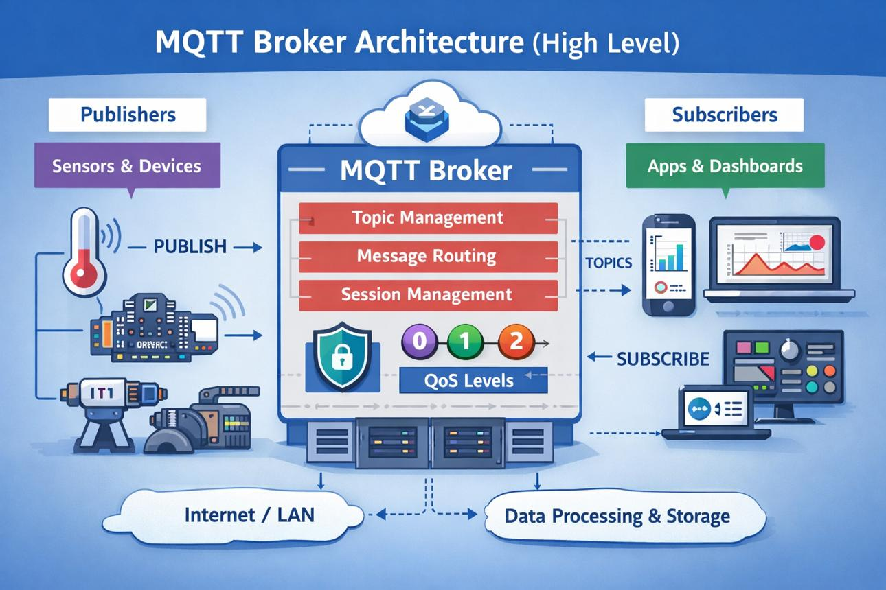

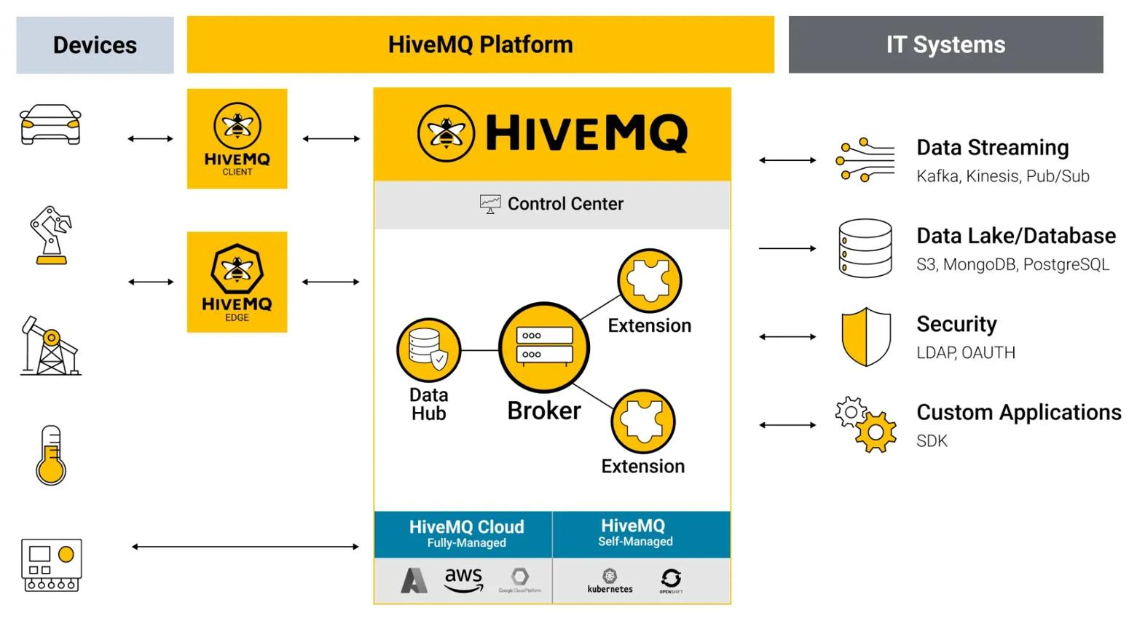
Comparison of MQTT Brokers
Feature | Eclipse Mosquitto | EMQX | HiveMQ | RabbitMQ | VerneMQ
Type | Open Source | Open Source / Enterprise | Enterprise + Community | Messaging Broker with MQTT Plugin | Open Source
Language | C | Erlang | Java | Erlang | Erlang
MQTT Version | 3.1, 3.1.1, 5.0 | MQTT 5.0 | MQTT 5.0 | MQTT Plugin Support | MQTT 5.0
Scalability | Small–Medium | Very High | Very High | High | High
Clustering | Limited | Excellent | Excellent | Excellent | Excellent
Lightweight | ✔ | Moderate | Moderate | Heavy | Moderate
Best Use Case | Embedded/IoT devices | Large-scale IoT | Enterprise IoT | Enterprise messaging | Distributed IoT
Dashboard/UI | Basic | Advanced | Advanced | Advanced | Moderate
TLS/SSL Security | ✔ | ✔ | ✔ | ✔ | ✔
Cloud Integration | Limited | Strong | Strong | Strong | Good

Feature Analysis of Major MQTT Brokers

1. Eclipse Mosquitto
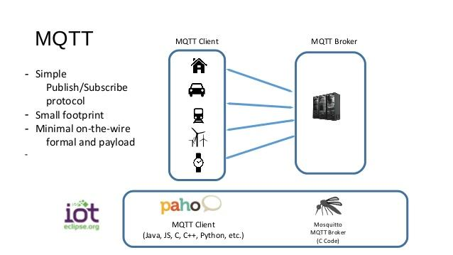

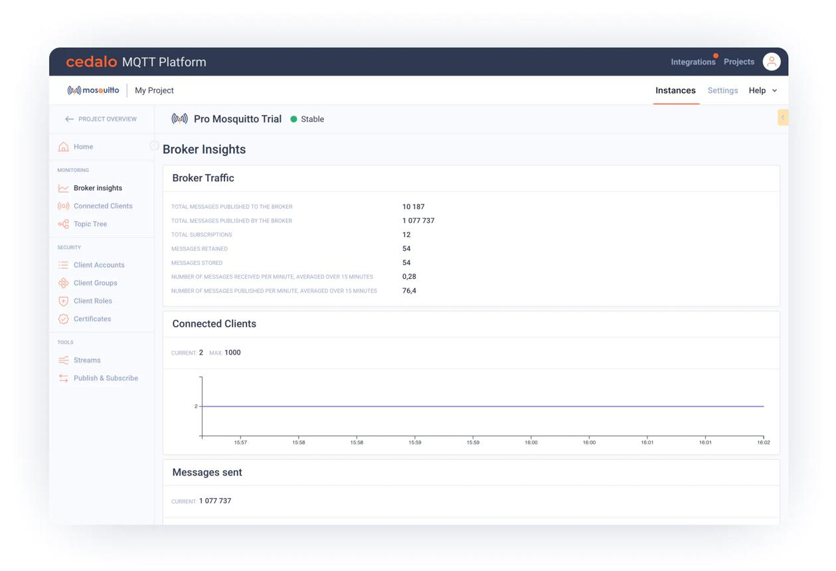
Features
- Lightweight and fast
- Suitable for Raspberry Pi and embedded devices
- Supports MQTT 5.0
- Simple installation and configuration
Advantages
- Low memory usage
- Open source
- Easy for beginners
Limitations
- Limited clustering support
- Not ideal for huge enterprise deployments

2. EMQX
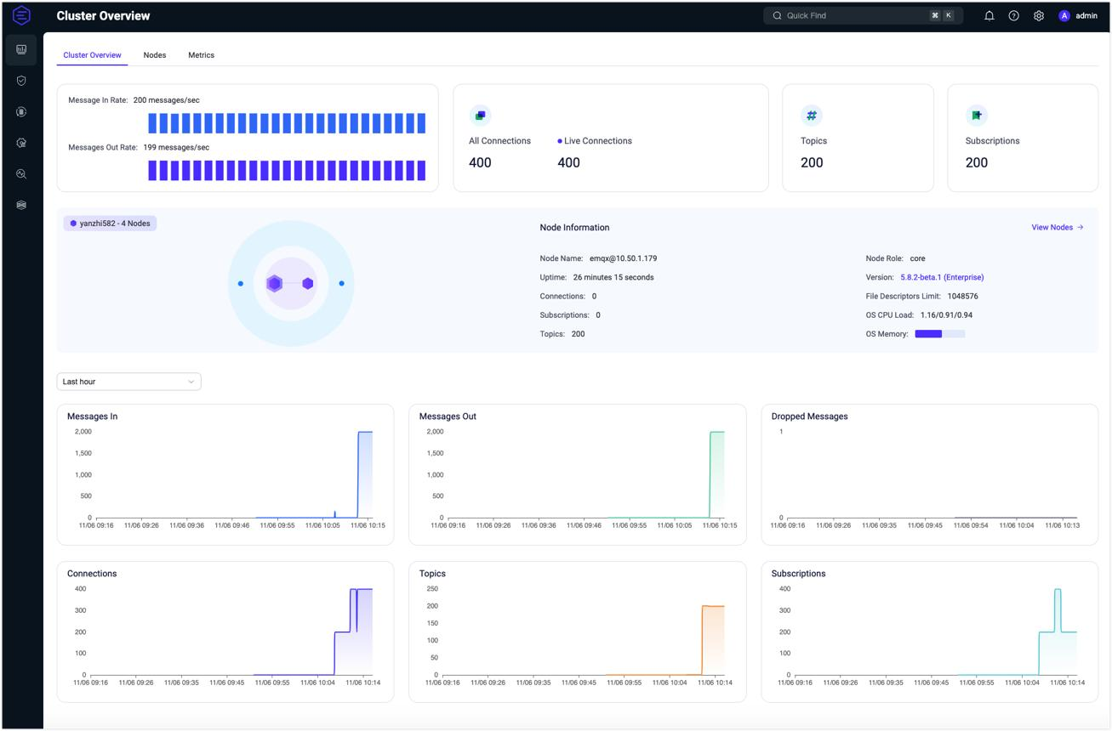
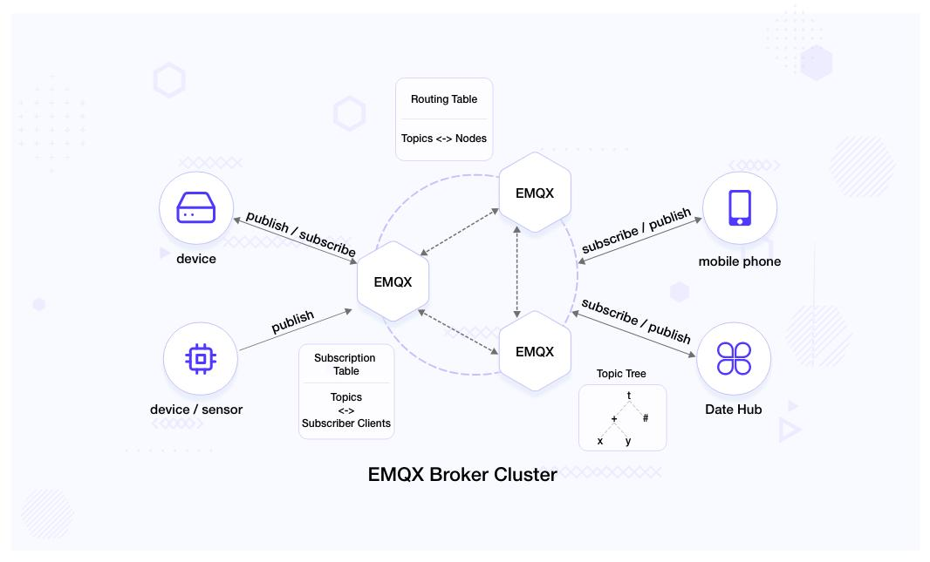
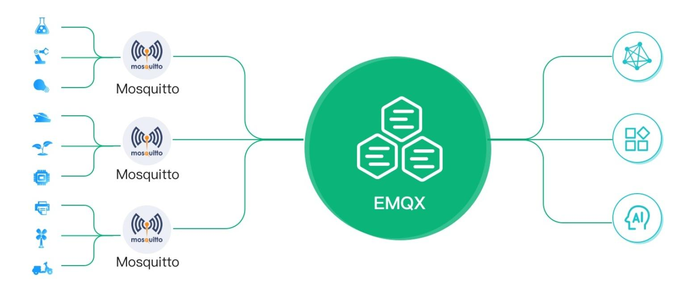

Features
- Massive scalability
- MQTT 5.0 support
- Advanced clustering
- Cloud-native architecture
Advantages
- Supports millions of devices
- High throughput and low latency
- Strong authentication and security
Limitations
- More complex setup
- Higher resource consumption

3. HiveMQ
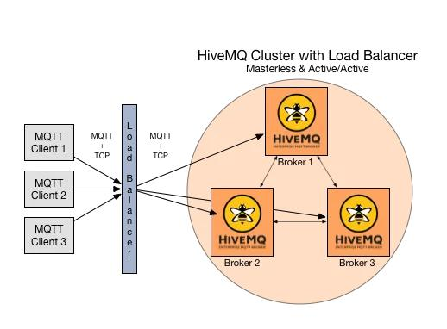
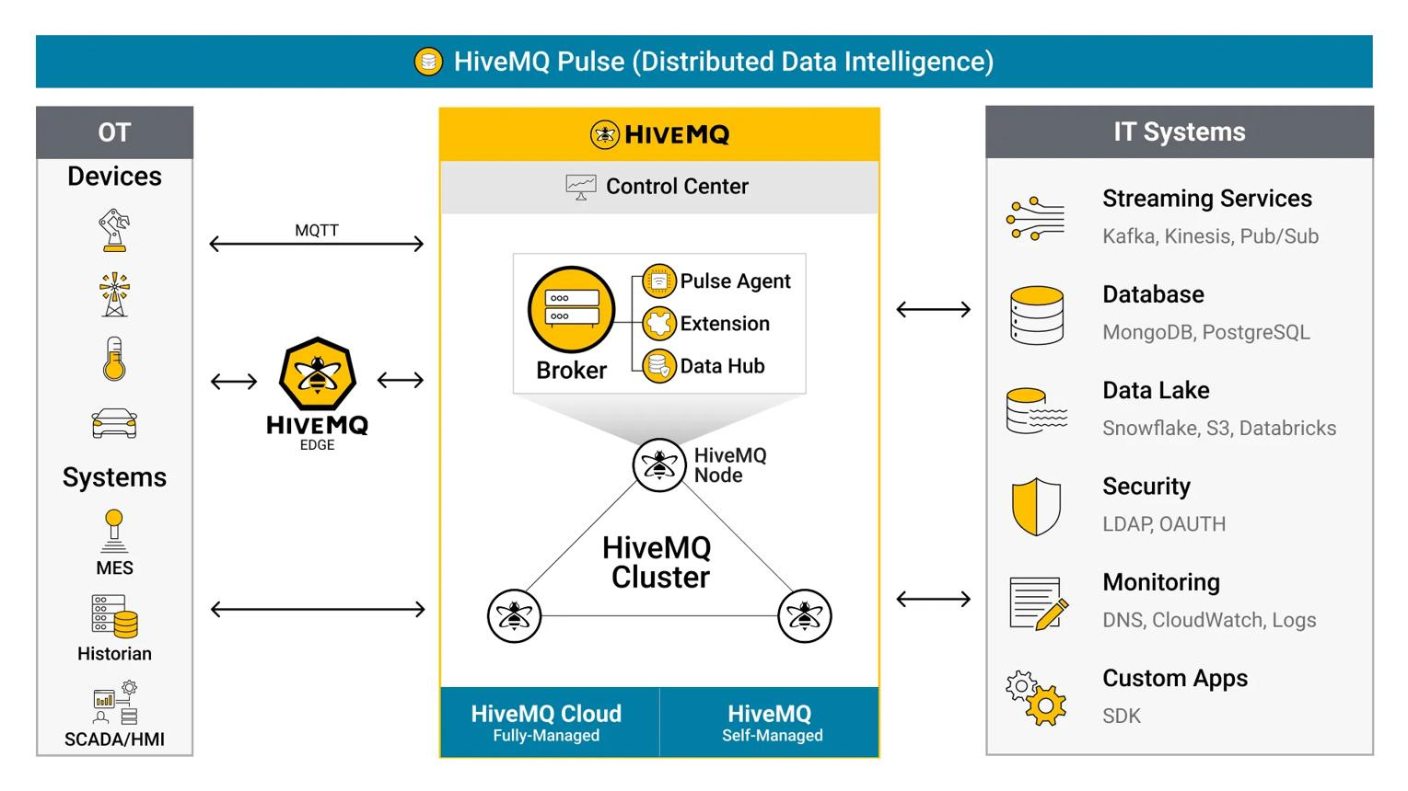
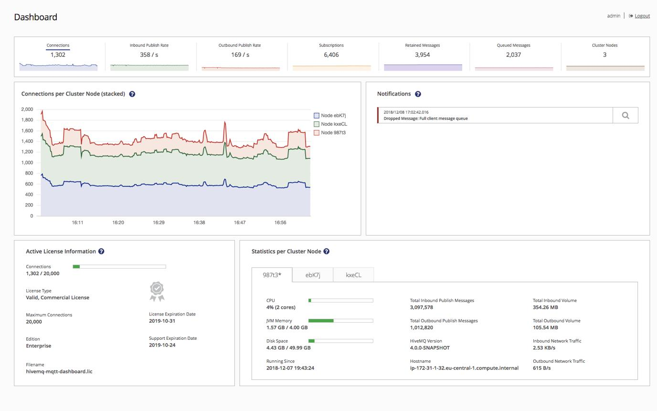
Features
- Enterprise-grade MQTT broker
- High availability clustering
- Advanced monitoring tools
Advantages
- Enterprise reliability
- Excellent scalability
- Strong MQTT 5 support
Limitations
- Commercial licensing for advanced features
- Higher infrastructure requirements

4. RabbitMQ
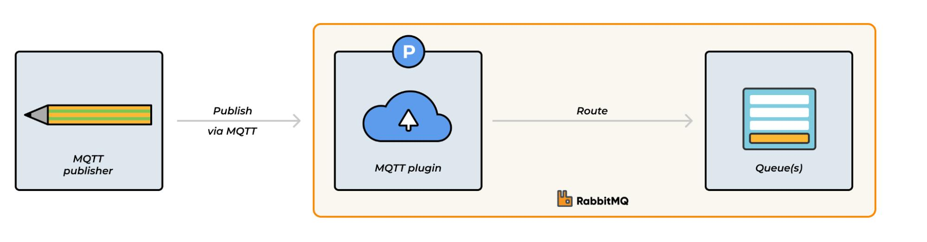
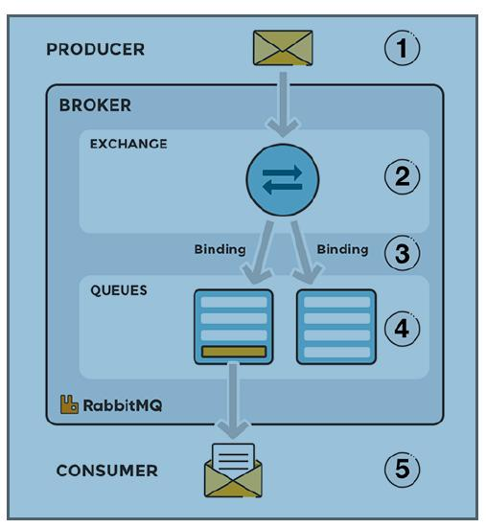
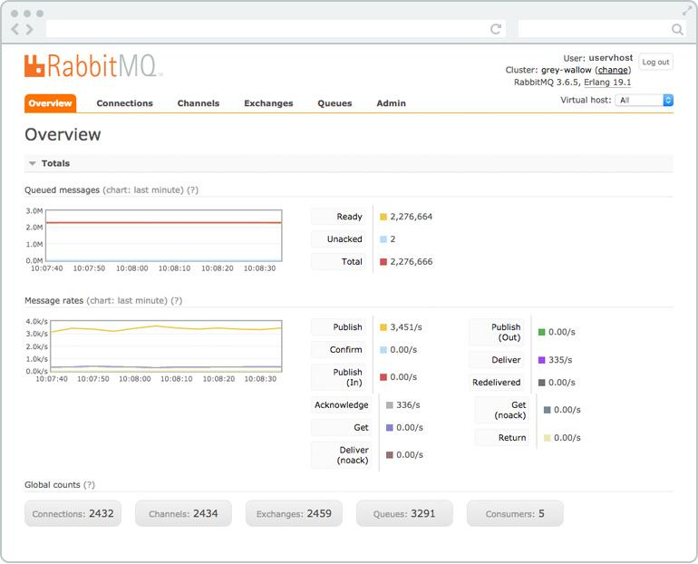

Features
- General-purpose message broker
- MQTT plugin support
- AMQP + MQTT integration
Advantages
- Flexible messaging system
- Enterprise integration support
Limitations
- Heavier than dedicated MQTT brokers
- MQTT not its primary specialization

5. VerneMQ

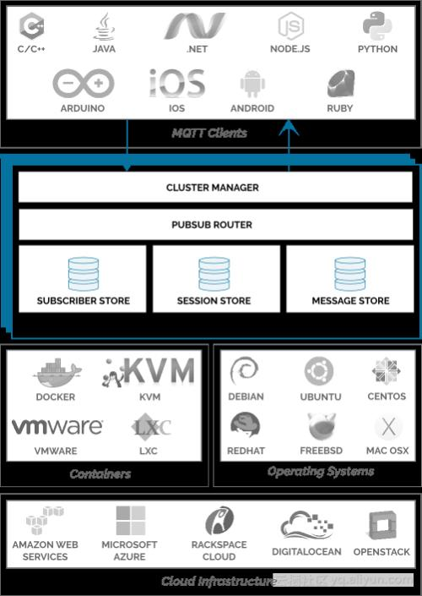

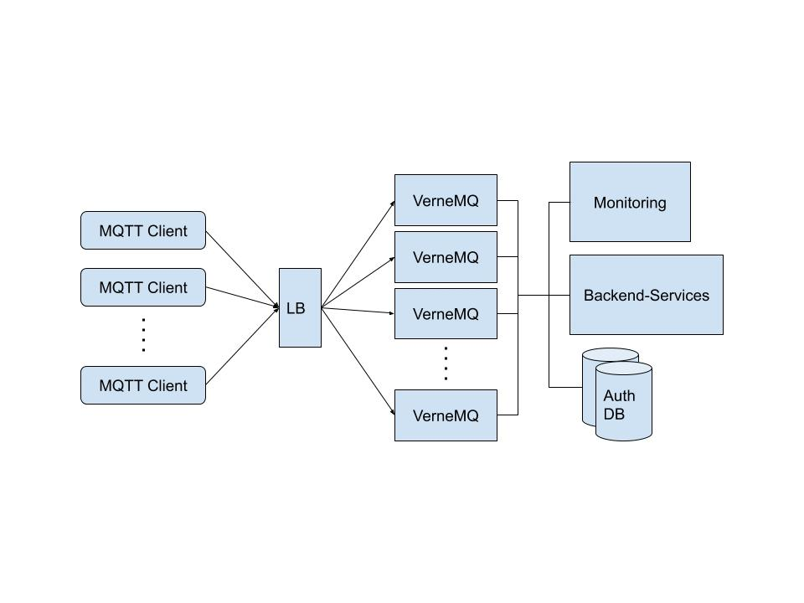

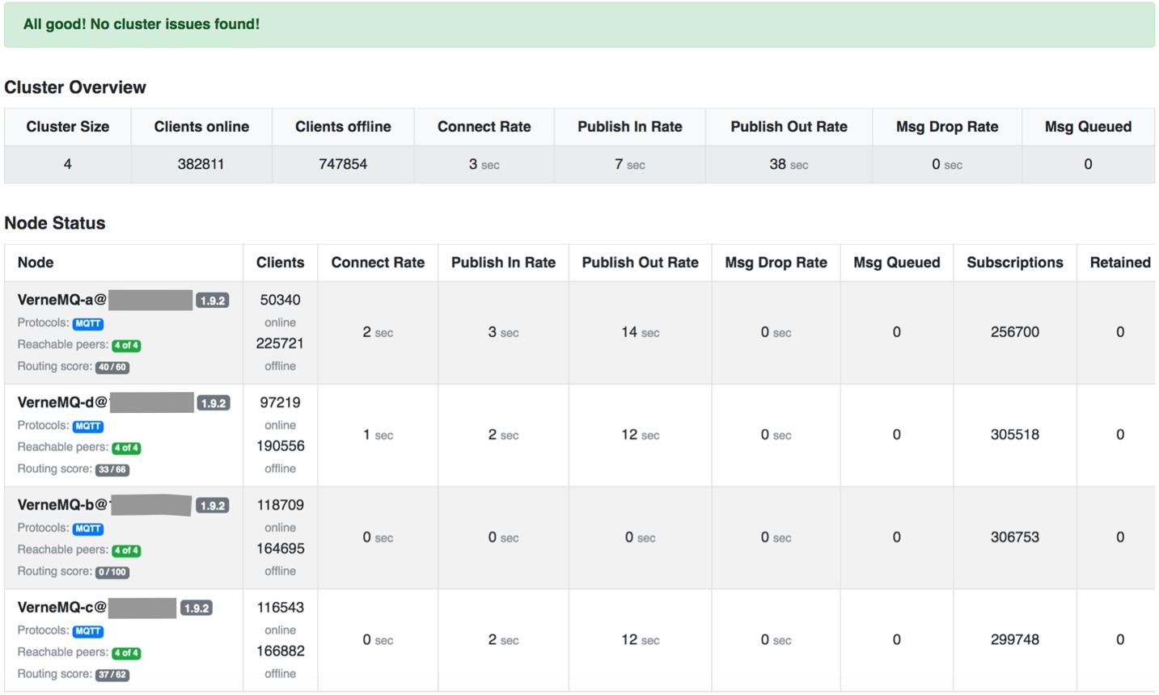
Features
- Distributed MQTT broker
- Fault-tolerant architecture
- Horizontal scalability
Advantages
- Good clustering support
- Reliable for distributed systems
Limitations
- Smaller ecosystem compared to EMQX/HiveMQ

Overall Comparison Summary

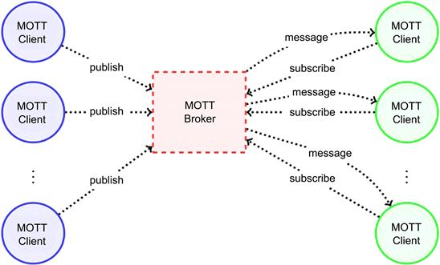

Best Choices Based on Use Case
- Small IoT Projects → Eclipse Mosquitto
- Large-scale IoT → EMQX
- Enterprise Systems → HiveMQ
- Message Queue Integration → RabbitMQ
- Distributed IoT Systems → VerneMQ

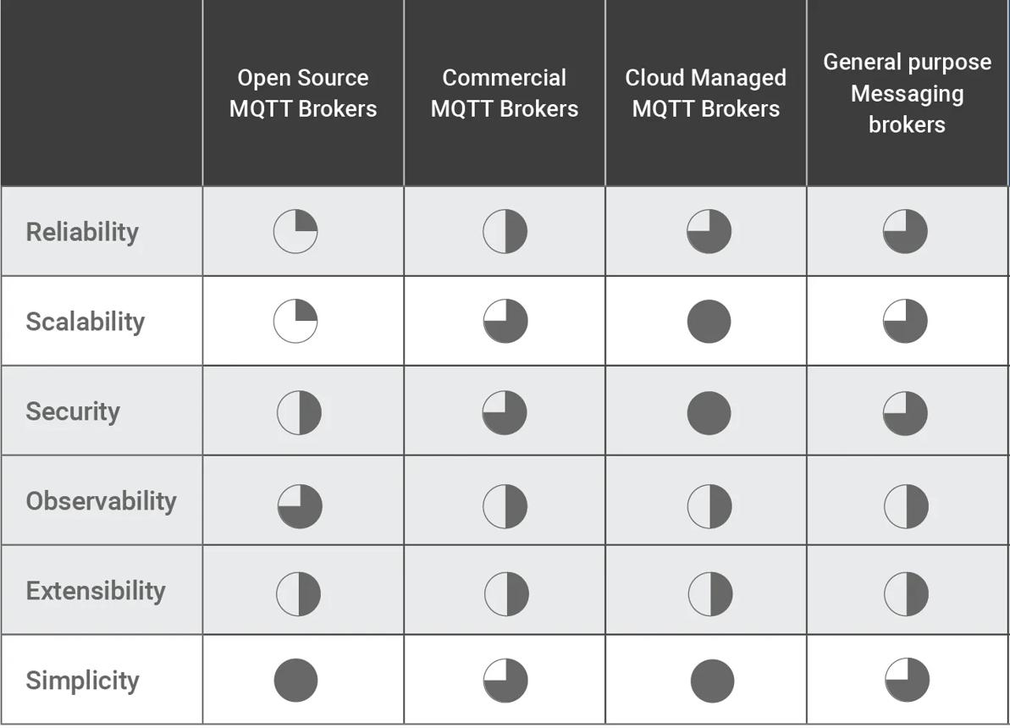

Conclusion
MQTT client libraries and brokers are essential components of IoT systems.
- Client libraries enable applications to publish and subscribe to messages.
- Brokers manage communication between IoT devices.
- Lightweight brokers like Mosquitto are ideal for embedded systems.
- Enterprise brokers like EMQX and HiveMQ support large-scale deployments.
Proper selection depends on:
- Scalability
- Performance
- Security
- Resource requirements
- IoT application size

